Python Introduction

Python Overview

1. Scripting Language
2. Object Oriented
3. Portable
4. Powerful
5. Easy to Learn and Use
6. Mixes good features from Java, Perl and Scheme

Major Uses of Python

1. Systm Utilities:
2. GUI’s (TKinter, gtk, Qt, Windows): Make Interactive GUI Applications with the help of the mentioned tools)
3. Internet Scripting:
4. Embedded Scripting:
5. Database Programming:
6. Artificial Intelligence:
7. Image Processing:

Installation

On Google type “PYTHON” select the first link which is highlighted on the below screen shot

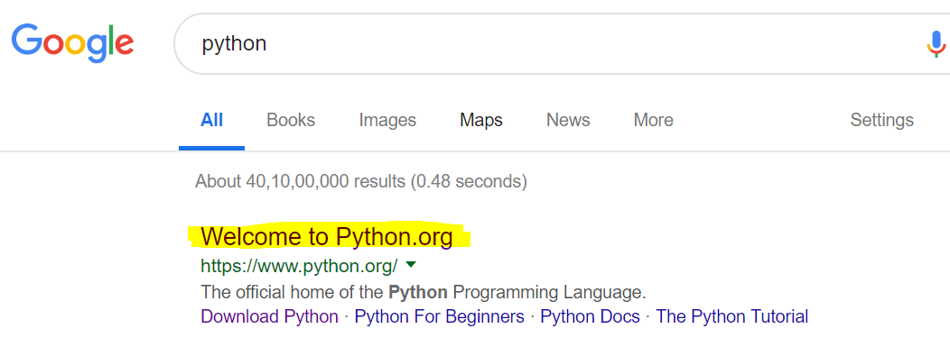

Many Languages require to compile (translate) the program into a form that the machine understand

Hello, Welcome to Python

Output

Execute

Compile

Python is instead directly interpreted into machine instructions (Means it is an Interpreted language doesn’t required to compile the source code)

Compile

Hello, Welcome to Python

Output

In Command line or shell(IDE) we can use python commands

Print (“text”) : Print the text on the screen. Before python 3.4 there is no use of giving the brackets.

5+56; It will add the numbers. Value – 61

-34+4; It will subtract the numbers. Value -- -30

4-45; It will subtract the numbers. Value -- -41

21/7; It will divide the numbers and return is Integer. Value – 3.0

23/7; It will divide the numbers and return us Integer with decimal. Value – 3.28571428571….

23//7; It will divide the numbers and return is whole number. Value – 3

57.23432/3.2222; It will divide the number. Value – 17.76238742233….

56*4; It will multiple the numbers. Value – 224

2*2*2; It will multiple the numbers. Value – 8

2**3; It is exponent of the numbers. Double asterisk is used as power Value – 8

**Order of the operation**

PEMDAS – Parenthesis, Exponent, Multiplication, Division, Addition, Subtraction

Eg: 3*4+5-6/2 = 14 instead of 5.5 as per the PEMDAS rules

Variables : Variable is an container of the value. They are used when value is not unknow. Eg when we don’t know what value user’s will be give or used.

Rules for Naming Conversion

1. Case sensitive
2. It is better to have name as myVal to declare the Name

Input(): It is used to prompt for the value to be entered at run time and store to the assigned variable. When number is assign it will store as a text but not as an integer. So it is necessary to convert to the integer

Sy: input(“message”)

Val=input(“Enter the value”)

At run time to prompt to enter value and store in val variable

Val=int(input(“Enter the value”) – now the input value will be converted to integer

Val= float(input(“Enter the value”) – now the input value will be converted to float

Built-in function : A peace of code which execute the logic

Eg instead of using 2**5, we can use the built-in function pow(2,5)

To the python built-in function use dir(__builtins__)